GUNNE SRI HARSHITH
AI Engineer
📧 sriharshith0511@gmail.com | 📱 +919014825007
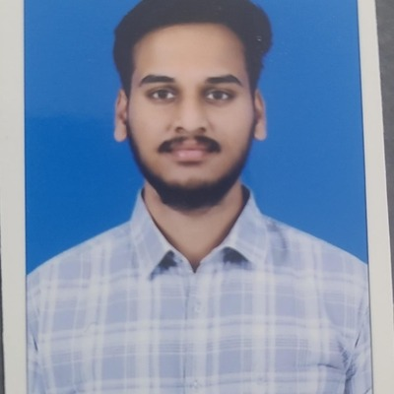
Verified Government ID Document
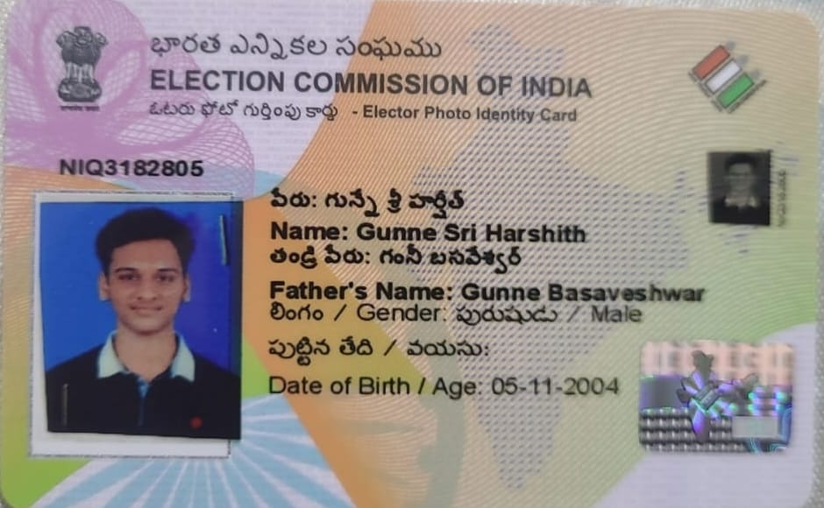

Original Candidate Resume
